**DAILY ONLINE ACTIVITIES SUMMARY**

|  |  |  |  |  |  |  |  |  |
| --- | --- | --- | --- | --- | --- | --- | --- | --- |
| **Date:** | **05-06-2020** | | | | | **Name:** | **Shiza Amreen.J** | |
| **Sem & Sec** | **4th sem B sec** | | | | | **USN:** | **4AL18CS078** | |
| **Online Test Summary** | | | | | | | | |
| **Subject** | | **--** | | | | | | |
| **Max. Marks** | | **--** | | **Score** | | | **--** | |
| **Certification Course Summary** | | | | | | | | |
| **Course** | **Introduction to Cyber Security** | | | | | | | |
| **Certificate Provider** | | | **GreatLearning** | | **Duration** | | | **5.5 Hours** |
| **Coding Challenges** | | | | | | | | |
| **Problem Statement: Write a Java Program to find the duplicate characters in a string.** | | | | | | | | |
| **Status: Completed** | | | | | | | | |
| **Uploaded the report in Github** | | | | | **yes** | | | |
| **If yes Repository name** | | | | | **Lockdown_Coding** | | | |
| **Uploaded the report in slack** | | | | | **yes** | | | |

Certification Course Details:

Today I have taken the course Introduction to Cyber Security from GreatLearning.

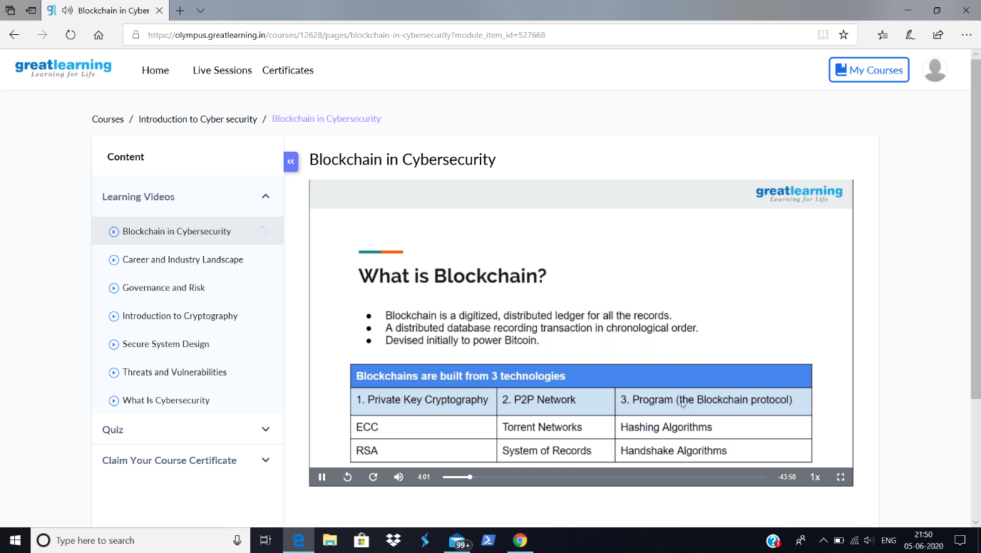

Coding Challenges Details:

**Problem Statement: Write a Java Program to find the duplicate characters in a string.**

**I have written the code for above given problem statements and have uploaded it in my github repository, Lockdown_Coding.**

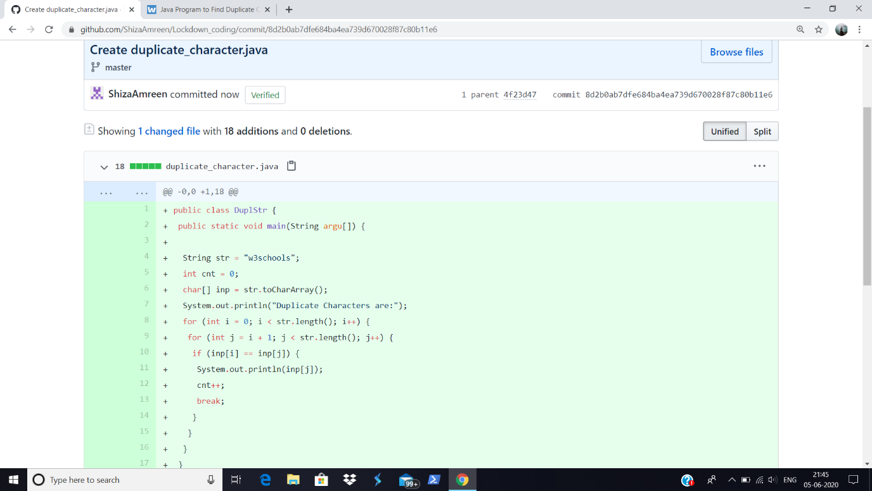

<https://github.com/ShizaAmreen/Lockdown_coding/commit/8d2b0ab7dfe684ba4ea739d670028f87c80b11e6>